Sanborn Regional Middle School
, December 6, 2019 ~ Today is an “A” Day
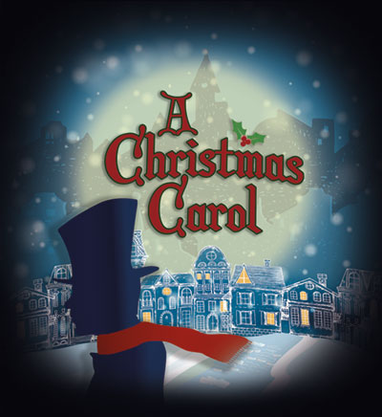

The Sanborn Community Presents:
A Christmas Carol - SRHS Auditorium
Friday December 6, 7:00 PM
Saturday Matinee, December 7, 2:00 PM

Ski Club will be starting soon. It will be on Thursdays after school for 6 weeks starting
January 9. Sign-up paperwork is available from Mrs. Bell, and spaces are
on a first come first served basis.
Winter Band Concert
Tuesday, December 10, 6:30 PM
SRHS Auditorium

- AFTER-SCHOOL ACTIVITIES
DATE | December 6  Friday | December 9  Monday | December 10  Tuesday | December 11  Wednesday | December 12  Thursday
Clubs and Activities | A Christmas Carol  7:00 PM  SRHS Auditorium | Student Council  2:30-3:30 | Winter Band Concert  6:30 PM  SRHS Auditorium | GEOGRAPHY BEE  SRHS AUDITORIUM  Jazz Band Rehearsal  4:00-5:30 SRHS
Basketball | BOYS A - AWAY @ HILLSBORO/DEERING*  1:30 dismissal – 3:00  BOYS B - PRACICE  5:00-6:30 SRMS  GIRLS A - AWAY @  HILLSBORO/DEERING*  1:30 dismissal-5:00  GIRLS B - PRACTICE 2:30-4:00 - SRMS  *6 HILLCAT DRIVE, HILLSBORO | BOYS A  HOME  3:30 SWASEY  Bus 203/206  BOYS B  AWAY  5:00  GIRLS A  HOME  3:30 SWASEY  Bus 203/206  GIRLS B  AWAY  3:30 | BOYS A  4:30-6:00 SWASEY  BOYS B  5:00-6:30 SRMS  GIRLS A  3:00-4:30 SWASEY  Bus 203  GIRLS B  2:30-4:00 SRMS | BOYS A  HOME  5:00 SWASEY  Bus 203/206  BOYS B  5:00-6:30 SRMS  GIRLS A  HOME  3:30 SWASEY  Bus 203/206  GIRLS B  3:30-5:00 SRMS | BOYS A  3:00-4:30 SWASEY  Bus 203  BOYS B  5:00-6:30 SRMS  GIRLS A  4:30-6:00 SWASEY  GIRLS B  2:30-4:00 SRMS

- DATES TO KEEP IN MIND

- Friday, December 6 – School Play, A Christmas Carol – 7:00 PM, SRHS Auditorium
- Saturday, December 7 – School Play, A Christmas Carol – 2:00 PM Matinee, SRHS Auditorium
- Tuesday, December 10 – Middle & High School Band Concert, 6:30 PM, SRHS Auditorium
- Wednesday, December 11 – GEOGRAPHY BEE – SRHS Auditorium – 9:00 AM to Finale

